

Name | Muhammad Mustafa Khan
Sap-Id | 53312
Course | Mobile App Development
Course Instructor | Sir Muhammad Usman
Project Name | Focus Flow
Semester | 05
Section | SE5-1

Project Report
Introduction:
FocusFlow is a mobile productivity application developed using Flutter and Dart. Its core function is to enhance user focus and time management by implementing the Pomodoro Technique.
The application provides a simple yet powerful tool that:
- Breaks work down into manageable, timed intervals.
- Integrates a focus timer with a CRUD task management system.
- Utilizes Firebase for secure user authentication and real-time data storage (Cloud Firestore).
Application Architecture and Workflow:
The application operates on a clear, user-centric workflow managed by a central navigation structure:
- Authentication: Users securely log in or sign up via Firebase Authentication.
- Core Interface: A main interface provides two primary screens: the Home screen (Focus Timer) and the Tasks screen (To-Do List).
- Task Management: Users manage tasks (Create, Read, Update, Delete) on the Tasks screen. All data is tied to the unique user ID and stored in Cloud Firestore for real-time synchronization.
- Timer Integration: Selecting a task and pressing "start" seamlessly links the task to the main timer, initiating the focus cycle.
- Focus Cycle: The timer strictly follows the Pomodoro principle: a dedicated work period on the selected task, followed by a scheduled break.
That's a great suggestion for a comprehensive project report! Having three dedicated sections for the main screens will make the report very clear.
Here is the expanded content, keeping the clean, humanized, and concise style:
Role as a Specific Screen (Home.dart):
The Home.dart file is the central control panel of the application, dedicated entirely to the Pomodoro Timer logic and user motivation.
- Timer Implementation: It houses the core logic for the countdown timer. This involves managing the timer state (Running, Paused, Break), handling the transition between focus and break periods, and using Timer.periodic for accurate time updates in Dart.
- Inter-Screen Communication: It acts as the receiver for the task data passed from the Tasks.dart screen via a callback, displaying the current task title to ensure the user maintains focus.
- State Persistence & Completion Logic:
  - It manages the count of completed Pomodoro sessions.
  - Upon a successful session completion, it triggers a function to update the corresponding task's status in the Cloud Firestore database.
  - It uses local state management (e.g., setState) to instantly update the circular progress bar and time display on the screen.
- User Controls: The screen provides clear UI elements for users to:
  - Start/Pause the current timer session.
  - Reset the current timer cycle.

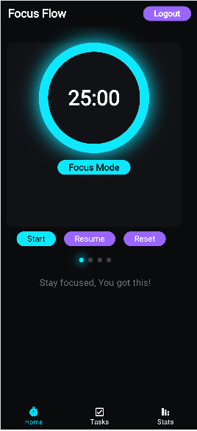
Role of the Task Management Screen (Tasks.dart):
The Tasks.dart file is critical, serving as the central hub for task management and data interaction:
- Data Model: It defines the structure of a Task object (ID, title, status) and includes methods (toJson, fromSnapshot) for seamless data handling with Firestore.
- Real-time Display: It uses a StreamBuilder to listen for real-time changes in the user's Firestore task collection, ensuring the UI is always up-to-date without manual refresh.
- User Interface (UI): It provides all interaction elements, including:
  - A dialog to add new tasks.
  - Checkboxes to toggle task completion status.
  - A delete function to remove tasks.
  - A "start" button that uses a callback function (onStartTask) to communicate the chosen task to the main timer widget.
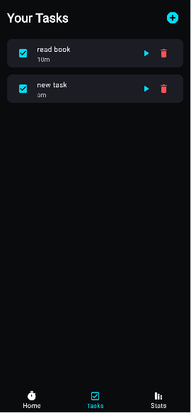
Role as a Specific Screen (Stats.dart):
The Stats.dart file is the reporting and analytics component of the application, designed to give the user insightful feedback on their productivity.
- Data Retrieval: It queries the Cloud Firestore database for historical session data, retrieving records of all completed Pomodoro cycles.
- Data Aggregation and Calculation: The screen logic calculates key productivity metrics, such as:
  - Total number of completed Pomodoros (lifetime and weekly).
  - Total focused time in hours/minutes.
  - Breakdown of focused time per project or task category (if applicable).
- Data Visualization: It utilizes visualization widgets (e.g., a Chart library like fl_chart) to render the data in an easy-to-digest format. Common visualizations include:
  - A Bar Chart showing daily focused time over the last week.
  - A Pie Chart illustrating the proportion of time spent on different tasks.
- Summary Reporting: It presents a quick-view summary of the user's recent performance, promoting goal-setting and self-reflection on work habits.
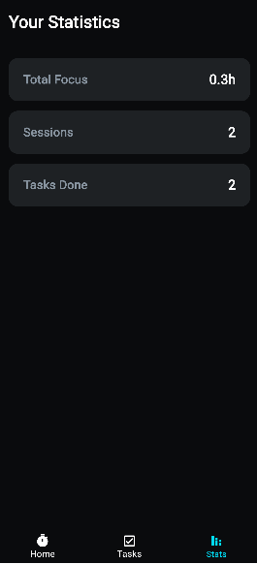

Development Exposure
This project provided extensive exposure to modern mobile development challenges and practices:
- Flutter & Dart Fundamentals: Deep experience with key concepts like StatefulWidget life-cycles, UI composition (ListView.builder), and asynchronous programming (async/await).
- Firebase Integration: Practical implementation of Firebase Authentication (for user state/ID) and Cloud Firestore (for real-time data streaming and querying).
- State Management: Implementation of a callback-based approach for efficient inter-widget communication (e.g., child widget informing a parent widget).
- Native Build Troubleshooting: Critically involved in diagnosing and resolving complex, native Android build system errors. This included:
  - Fixing syntax errors in Gradle files.
  - Resolving dependency conflicts by upgrading key versions (AGP, Kotlin, SDK).
  - Correcting configuration settings (minSdk, compileSdk) for various Flutter and Firebase plugins.
- Code Quality: Addressed code analysis warnings (flutter analyze), notably fixing the critical use_build_context_synchronously issue to prevent runtime crashes.
Summary:
The FocusFlow project is a robust, well-structured Flutter application that successfully combines the Pomodoro Technique with Firebase backend services. The development process was invaluable for gaining hands-on experience in real-time data synchronization, cross-widget state management, and, most significantly, resolving complex native build system and dependency errors—ensuring the application is not only fully functional but also stable and compliant with modern mobile development standards.

